**CC1**

QUESTION :1

| package com.DAY7.DAY7; import org.openqa.selenium.By; import org.openqa.selenium.WebDriver; import org.openqa.selenium.chrome.ChromeDriver; import org.openqa.selenium.chrome.ChromeOptions; import io.github.bonigarcia.wdm.WebDriverManager; public class CCQ1 {  public static void main( String[] args ) throws InterruptedException  {  ChromeOptions co=new ChromeOptions();  co.addArguments("--remote-allow-origins=*");  WebDriverManager.chromedriver().setup();  WebDriver driver=new ChromeDriver(co);  driver.navigate().to("https://www.saucedemo.com/");  driver.manage().window().maximize();    driver.findElement(By.xpath("//*[@id=\"user-name\"]")).sendKeys("standard_user");  driver.findElement(By.xpath("//*[@id=\"password\"]")).sendKeys("secret_sauce");  driver.findElement(By.xpath("//*[@id=\"login-button\"]")).click();  Thread.sleep(1000);    //add to cart  driver.findElement(By.xpath("//*[@id=\"add-to-cart-sauce-labs-backpack\"]")).click();  Thread.sleep(5000);  //cart  driver.findElement(By.xpath("//*[@id=\"shopping_cart_container\"]/a")).click();  Thread.sleep(1000);  //1  String Cart=driver.findElement(By.xpath("//*[@id=\"cart_contents_container\"]/div/div[1]/div[3]/div[1]")).getText();  String inCart="1";  if(Cart.equals(inCart)) {  System.out.println("Added to Cart Successfully");  }  else {  System.out.println("Not Added to Cart");  }    //checkout  driver.findElement(By.xpath("//*[@id=\"checkout\"]")).click();  Thread.sleep(1000);  //form  driver.findElement(By.xpath("//*[@id=\"first-name\"]")).sendKeys("SUBBULAKSHMI ");  driver.findElement(By.xpath("//*[@id=\"last-name\"]")).sendKeys("L");  driver.findElement(By.xpath("//*[@id=\"postal-code\"]")).sendKeys("641 001");  Thread.sleep(1000);  //continue  driver.findElement(By.xpath("//*[@id=\"continue\"]")).click();  Thread.sleep(1000);    //check  String currCheckout=driver.findElement(By.xpath("//*[@id=\"header_container\"]/div[2]/span")).getText();  String expCheckout="Checkout: Overview";  if(currCheckout.equals(expCheckout)) {  System.out.println("Checkout Text is Matched");  }  else {  System.out.println("Checkout text is not Matched");  }  //name and price of the product  String name = driver.findElement(By.xpath("//*[@id=\"item_4_title_link\"]/div")).getText();  System.out.println("The Name Of The Product :"+name);  String price = driver.findElement(By.xpath("//*[@id=\"checkout_summary_container\"]/div/div[2]/div[8]")).getText();  System.out.println(price);  Thread.sleep(5000);     //Swag Labs  String currentTitle=driver.getTitle();  System.out.println(currentTitle);  String expectedTitle="Swag Labs";  if(currentTitle.equals(expectedTitle)) {  System.out.println("Title Matched");  }  else {  System.out.println("Title not Matched");  }  Thread.sleep(5000);     //url  String currentUrl=driver.getCurrentUrl();  String expectedUrl="https://www.saucedemo.com/checkout-step-two.html";  if(currentUrl.equals(expectedUrl)) {  System.out.println("URL Matched");  }  else {  System.out.println("URL not Matched");  }  Thread.sleep(5000);   }  } |
| --- |
|  |

OUTPUT:

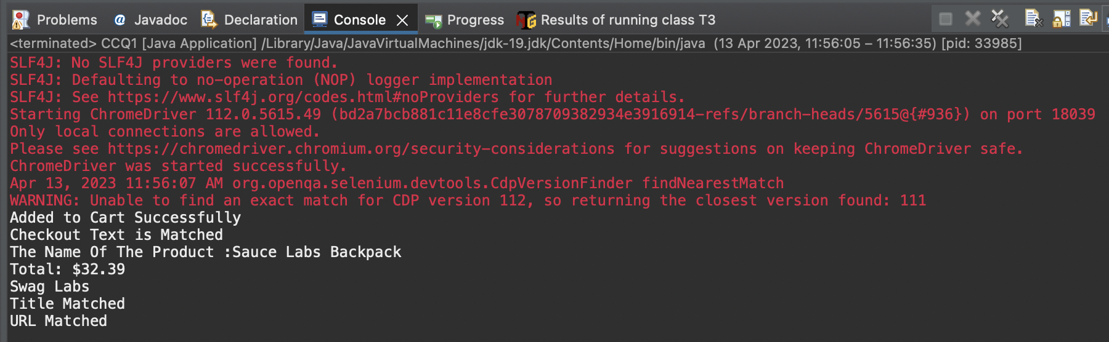

QUESTION :2

| package com.DAY7.DAY7; import org.openqa.selenium.By; import org.openqa.selenium.WebDriver; import org.openqa.selenium.chrome.ChromeDriver; import org.openqa.selenium.chrome.ChromeOptions; import io.github.bonigarcia.wdm.WebDriverManager; public class CCQ2 {  public static void main( String[] args ) throws InterruptedException{  ChromeOptions co=new ChromeOptions();  co.addArguments("--remote-allow-origins=*");  WebDriverManager.chromedriver().setup();  WebDriver driver=new ChromeDriver(co);    driver.get("https://www.saucedemo.com/");  driver.findElement(By.xpath("//*[@id=\"user-name\"]")).sendKeys("standard_user");  driver.findElement(By.xpath("//*[@id=\"password\"]")).sendKeys("secret_sauce");  driver.findElement(By.xpath("//*[@id=\"login-button\"]")).click();  Thread.sleep(3000);    String A_z=driver.findElement(By.xpath("//*[@id=\"item_4_title_link\"]/div")).getText();  System.out.println("1st Product in A-Z: "+A_z);  driver.findElement(By.xpath("//*[@id=\"header_container\"]/div[2]/div/span/select")).click();  driver.findElement(By.xpath("//*[@id=\"header_container\"]/div[2]/div/span/select/option[2]")).click();  System.out.println("1st Product in Z-A: "+driver.findElement(By.xpath("//*[@id=\"item_3_title_link\"]/div")).getText());  driver.findElement(By.xpath("//*[@id=\"header_container\"]/div[2]/div/span/select")).click();  driver.findElement(By.xpath("//*[@id=\"header_container\"]/div[2]/div/span/select/option[3]")).click();  System.out.println("1st Product Price in the range Low to High: "+driver.findElement(By.xpath("//*[@id=\"inventory_container\"]/div/div[1]/div[2]/div[2]/div")).getText());  driver.findElement(By.xpath("//*[@id=\"header_container\"]/div[2]/div/span/select")).click();  driver.findElement(By.xpath("//*[@id=\"header_container\"]/div[2]/div/span/select/option[4]")).click();  System.out.println("1st Product Price in the range High to Low: "+driver.findElement(By.xpath("//*[@id=\"inventory_container\"]/div/div[1]/div[2]/div[2]/div")).getText());  }  } |
| --- |

OUTPUT:

